**Australian Islamic College 2018**

**ATAR Chemistry Units 3 and 4**

**Task 5 (Weighting: 3%)**

**Volumetric Analysis Test**

Test Time: 30 minutes

Please do not turn this page until instructed to do so.

|  |  |
| --- | --- |
| **First Name** | **Surname** |
|  |  |

|  |
| --- |
| **Teacher** |
| **ANSWERS** |

|  |  |
| --- | --- |
| **Mark / 21** | **Percentage** |
|  |  |

Equipment allowed: Pens, pencils, erasers, whiteout, rulers and non-programmable calculators permitted by the Schools Curriculum and Standards Authority.

**Special condition**: 2 marks will be deducted for failing to write your full name on this test paper.

Teacher help: Your teacher can only help you during your test in one situation.

If you believe there is a mistake in a question show your teacher and your teacher will tell you whether or not there is a mistake in the question and if appropriate, how to fix that mistake.

Questions must be answered in this booklet, in the spaces provided.

Total marks: 21

1. In a titration to determine the concentration of a hydrochloric acid solution using a sodium hydroxide standard solution the following results were collected.

|  |  |  |  |  |  |
| --- | --- | --- | --- | --- | --- |
|  | Trial 1 | Trial 2 | Trial 3 | Trial 4 | Trial 5 |
| Initial burette reading (mL) | 0.0 | 3.6 | 10.2 | 5.5 | 4.4 |
| Final burette reading (mL) | 25.3 | 27.6 | 34.3 | 31.6 | 28.6 |
| Titre (mL) | **25.3** | **24.0** | **24.1** | **26.1** | **24.2** |

What average value for the titre should be used for the calculations of the hydrochloric acid concentration? [1 mark]

**24.1 mL (1 mark; ½ off for wrong / no units)**

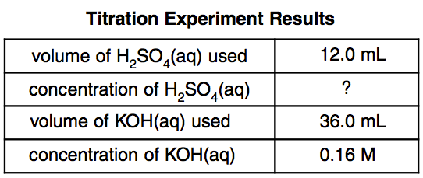

1. The table above summarises the results of a titration.
   1. Name the analyte. [1 mark]

**Sulfuric acid**

* 1. Name the standard solution. [1 mark]

**Potassium hydroxide (solution / aqueous)**

* 1. State one reason why the substance you named in part (b) is unlikely to have been the primary standard solution. [1 mark]

**It does not have a high molar mass / any other correct reason.**

* 1. Determine the concentration of the analyte. Express your answer to the appropriate number of significant figures. [1 mark]

**0.24 mol L-1 (or M)**

**½ mark off for wrong / no units. ½ mark off for not have two significant figures.**

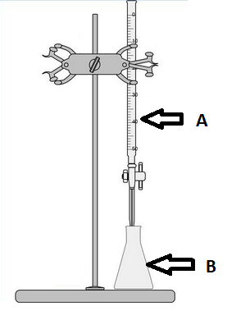

1. All of Question 3 refers to the diagram above.
   1. What is the name of the piece of equipment labelled ‘A’?

[1 mark]

**Burette**

* 1. With what should the final rinse of the piece of equipment labelled ‘B’ be performed? [1 mark]

**Distilled water / deionized water. No marks for just ‘water’.**

* 1. What word describes the measured volume of liquid dispensed from ‘A’ to reach the endpoint? [1 mark]

**Titre**

* 1. How is the endpoint typically recognised during an acid-base titration such as the ones performed in our classroom? [1 mark]

**By a change in colour of the indicator.**

* 1. How will the final calculation of analyte concentration be affected if, every time a titration is performed, the volumes in equipment ‘A’ are measured from the top of the meniscus instead of the bottom of the meniscus? Justify your answer. [2 marks]

**No change (1 mark)**

**Because the error in measurement of the initial volume will be compensated by an error of the same size and in the same direction in the measurement of the final volume. (1 mark)**

* 1. When preparing for a titration using the equipment above 1.54 g of primary standard was dissolved in 250 mL of distilled water instead of 1.45 g, as intended.
     1. What type of error will this cause? Circle the correct answer from the three choices below. [1 mark]

**Systematic** / Random / No error

* + 1. How will the final calculation of analyte concentration differ from the true value? Circle the correct answer from the three choices below. [1 mark]

Too high / **Too low** / No change

* 1. The equipment shown in the diagram at the start of this question was used to perform a titration. Hydrochloric acid was placed in the burette and a solution of sodium hydrogen carbonate was placed in the conical flask.

Sketch the titration curve on the grid below, label the vertical axis (Y-axis) appropriately and label the equivalence point.

[4 marks]

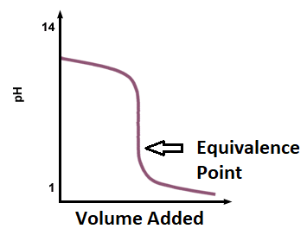

Vertical axis labelled with ‘pH’ and at least two numbers (1 mark).

Curve has starting point around pH 9 (1 mark), ending point around pH 1 (1 mark).

Equivalence point in the acidic range (1 mark).

1. To determine the purity of a sample of copper(II) oxide, a 20.56 g sample of the impure substance was reacted with 500.0 mL of 1.10 mol L-1 hydrochloric acid, an excess. After this reaction was complete a 25 mL aliquot of the acid was titrated against a standard solution of 0.100 mol L-1 NaOH. An average titre of 25.4 mL was required to reach the endpoint.

Determine the percentage purity of the copper(II) oxide and express your answer to the appropriate number of significant figures. [4 marks]

**HCl(aq) + NaOH(aq) 🡪 H2O(l) + NaCl(aq)**

**n(NaOH) = cV = 0.1 x 0.0254 = 0.00254 mol**

**SR = 1/1 = 1**

**n(HCl in 25 mL aliquot) = 0.00254 mol**

**(1 mark)**

**c(25 mL aliquot of HCl) = n / V = 0.00254 / 0.025 = 0.1016 mol L-1**

**c(HCl in 500 mL HCl after reaction with CuO) = 0.1016 mol L-1**

**n(HCl in 500 mL HCl after reaction)**

**= cV = 0.1016 x 0.5 = 0.0508 mol**

**n(HCl in 500 mL before reaction with CuO)**

**= cV = 1.10 x 0.5 = 0.55 mol**

**n(HCl used in reaction with CuO) = 0.55 – 0.0508 = 0.4992 mol**

**(1 mark)**

**CuO(s) + 2HCl(aq) 🡪 CuCl2(aq) + H2O(l)**

**SR = ½**

**n(CuO) = ½ x 0.4992 = 0.2496 mol**

**m(CuO) = nM = 0.2496 x (63.55 + 16) = 19.85568 g**

**(1 mark)**

**% purity = (19.85568 x 20.56) x 100 = 97 % (2 sf)**

**(1 mark; ½ mark off for no / wrong unit, ½ mark off for not having two significant figures).**

**END OF TEST**